**Self Portrait**

**Draft Portrait:**

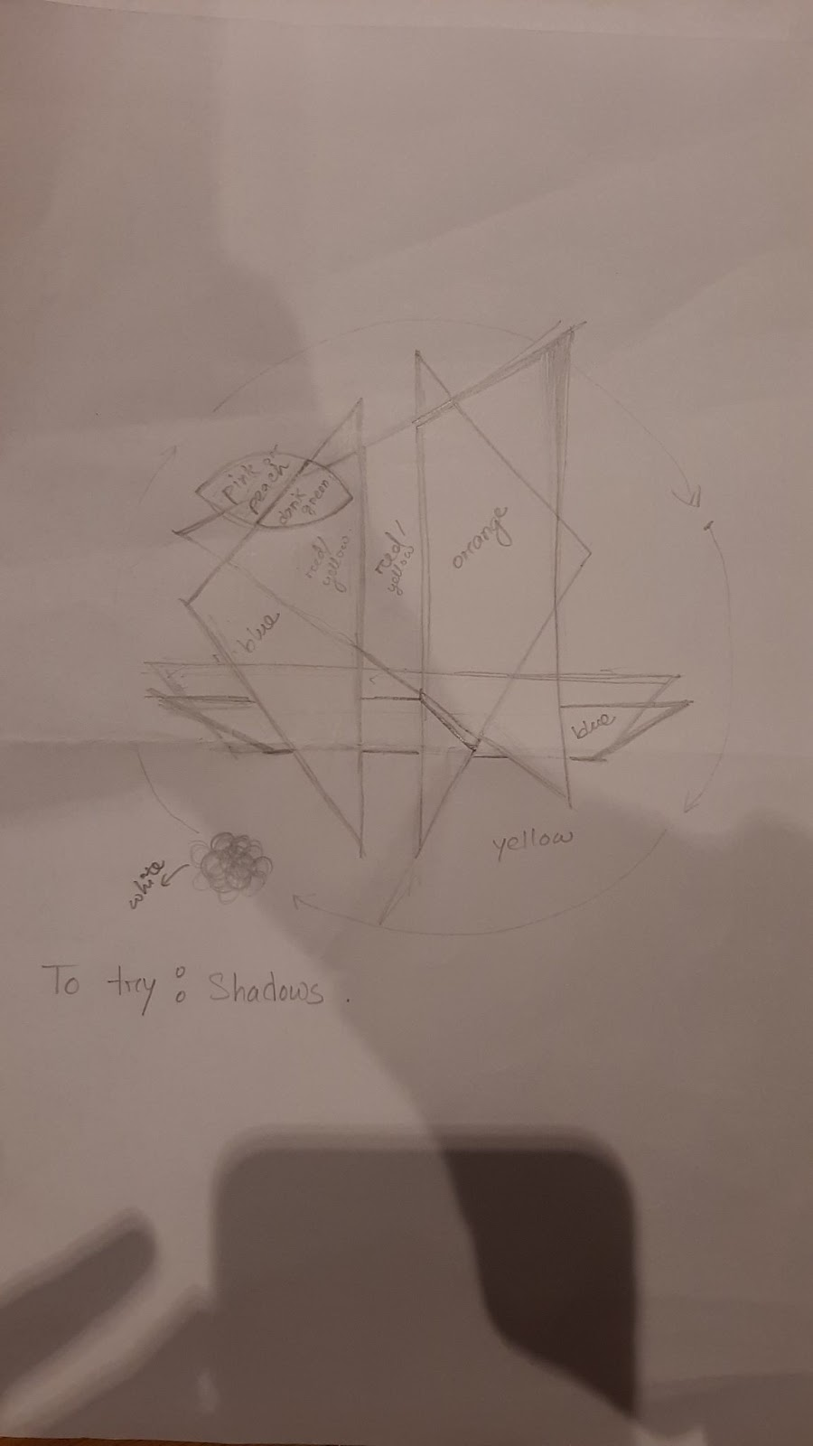

I tried viewing myself from Picasso’s geometric vision and used contrasting colors to express my emotions.

**Main Sketch:**

<https://editor.p5js.org/maishahoq/sketches/2C6WZVTUB>

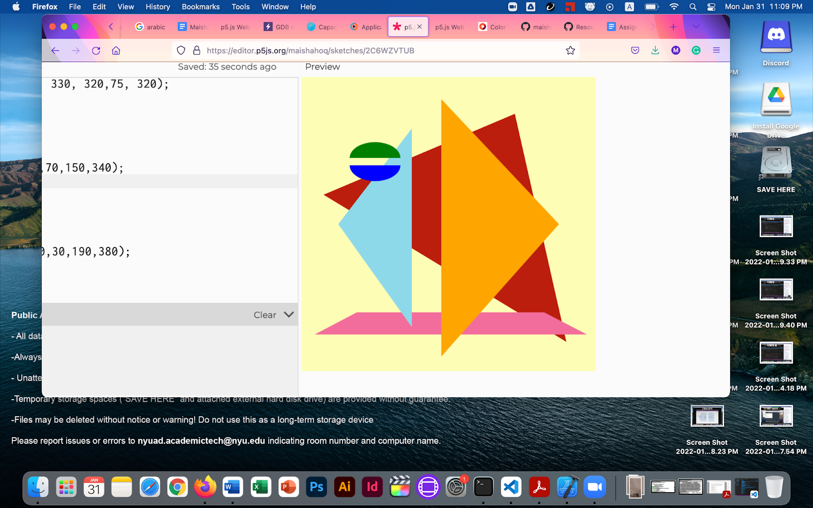

**Drawback:** The draft has a spiral rotating set of white rings, that I couldn’t implement due to lack of understanding of the rotate function.

Using straight line equations to find the intersection points of two shapes to ensure better placement of the smaller shapes and fragment colors on top.

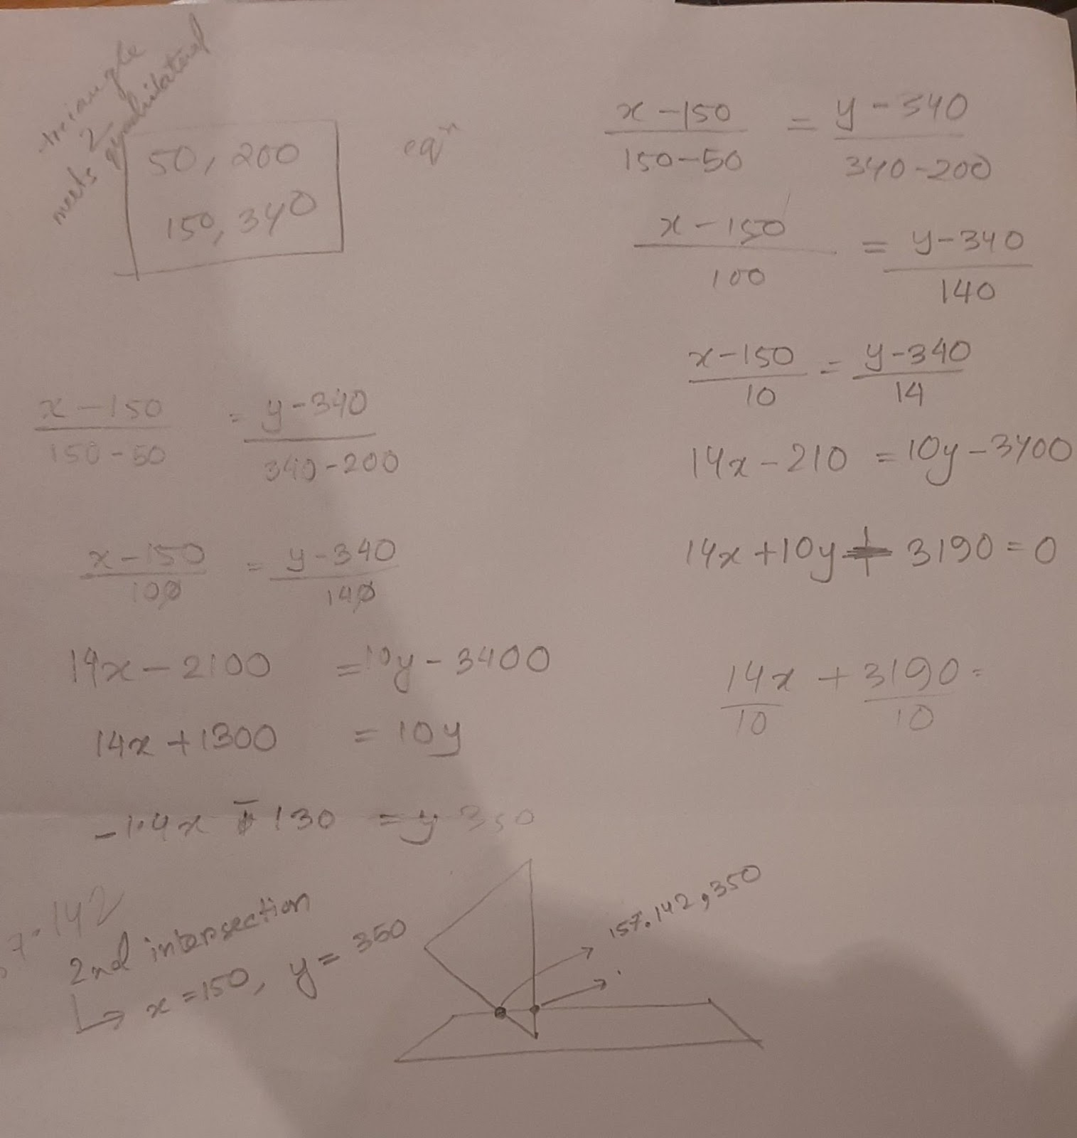

**Resources used:**

1. Color picker: <https://htmlcolorcodes.com/color-picker/>